W300D(V5.0)-How to setup the ADSL router?

Product line: ADSL Question Category: Internet settings

I. Physical connection:
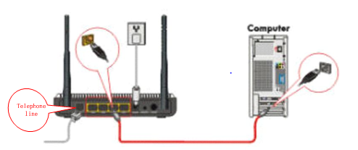
1. Connect the telephone line to the DSL port of the router.

2. Take an Ethernet cable to connect your computer with one of the yellow LAN port (1, 2, 3 or 4) of the router.

3. Check the LED lights. Making sure Power is on, the LAN port which you have plugged the cable in is on, the SYS and DSL are blinking.WLAN is on or blinking.

Note:If you can access internet through W300D after setting,the DSL light should be always on.
II. Login to the management page of the router:

1. Open a web browser (IE, Firefox, Safari, etc.) and find the address bar, leaving it blank before typing in 192.168.1.1, and then press enter.
(Care: The address bar is in the most top of the web page after opening web browser).
2. You will see Tenda Login page.
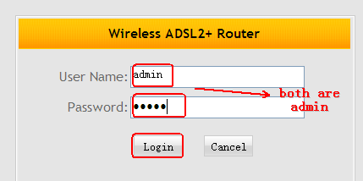
3. In the following page please select and input your information.
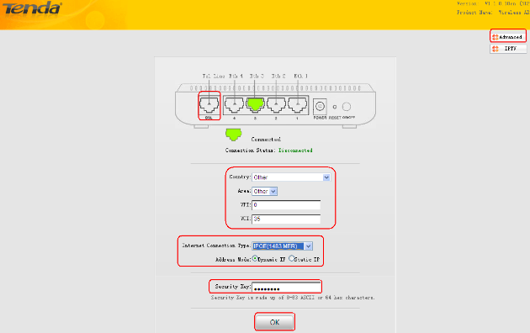
4. After reboot please click on Advanced in the right up side to check the Wan status.
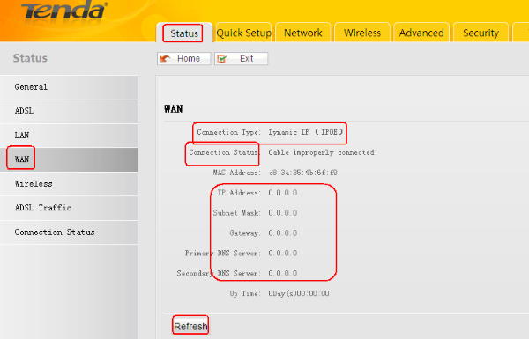
5.
A.Please check whether the Connection Type is correct.
B.If the Connection Status shows Connected, it means that you can go to internet now.
C. if the Connection Status shows Cable inproperly connected, please check whether you have connected your phone line to the DSL port correctly.
D. if the Connection Status shows Connecting, please do as the following pictures.
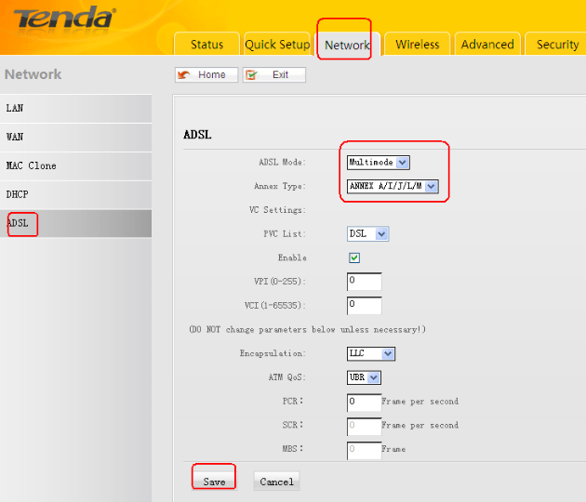
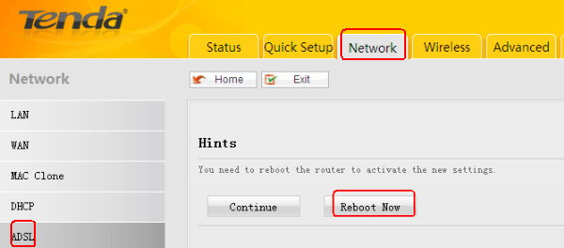
6.After reboot, please Go to check the Connection Status again, if it shows Connected, you can go to internet.
If it still shows connecting, please power off W300D for 5 minutes and power on.

